Exploring Factors of Reasons Animals Are Sent to Animal Shelters to Increase Adoption Rates

Adoption Rates in Animal Shelters

Haeven S. Butler

INFO 5810 – Section 002, University of North Texas, haevenbutler@my.unt.edu

Animal shelters are continuously overpopulated due to the six to eight million animals that enter shelters each year. Around 50% of those animals that enter shelters are euthanized and of that 50%, 25% of those animals are euthanized due to overcrowding. The goal of this study is to analyze the types of factors that lead to successful adoptions which vary between type of animal, condition of the animal, and the breed of animal, etc.

CCS CONCEPTS • Text association • K-Clustering • Descriptive Analysis Test

**Additional Keywords and Phrases:** Animal Shelters, Adoption, City of Dallas, Overpopulation, Overcrowding

1. Introduction

Domestic animals continue to overpopulate animal shelters every year. On average, six to eight million animals are sent to rescue shelters and of that number, 50% of the animals are euthanized, and around 25% of those animals are sentenced to death because of overcrowding (4). There are many factors that go into the length of stay for each animal varying from if the animal is a cat or dog, the age, gender, the type of breed, the size of the animal, and the location of the shelter. Specifically focusing on the City of Dallas, the goal of this study is to analyze the types of factors that lead to a successful adoption which can vary between the type of animal, the condition the animal, the breed of animal, etc.

Just this year alone (May 2022), the City of Dallas issued a Humane Pet Ordinance placing a ban on animals, specifically cats and dogs being sold in pet stores due to the overpopulation of these common household pets in local humane societies (5). The main goal of this ban was to limit the marketing of animals being sold from puppy mills. Puppy mills are places that breed puppies to sale in inhumane conditions. What this means is that animals are bred repeatedly to produce puppies to sell for financial gain. With the City of Dallas creating this ordinance to put in place, it requires for people that are looking to purchase a common household pet, they are being pushed to start at humane societies instead of going to a pet store first. There are still breeders that still sell through various social media platforms.

The main reason why they are pushing the Humane Pet Ordinance is to push the adoption rate in a positive direction at local humane societies in the Dallas-Fort Worth Metroplex area. The ordinance also helps to encourage the better treatment of animals. This information proposes three research questions that are listed down below:

**RQ1: What are the most popular breeds of cat and dog that get adopted?**

**RQ2: How many animals are euthanized based on overpopulation or the condition they’re brought in?**

**RQ3: How do these animals end up in animal shelters?**

1. Literature Review

In this section, we look at the research conducted about animal shelters and primarily focus on how to increase adoption rates in shelters and to prevent buyers buying from puppy mills.

This study was conducted help increase adoption rates in animal shelters to prevent them from getting euthanized due to overpopulation. The authors of this study used logistic regression, artificial neural network, gradient boosting, and random forest algorithms to develop different models to make predictions about the animal’s length of stay. As a result, the authors were able to figure out length of each animal’s stay based on what animal shelter they were in as well as helping decrease the euthanization rates [4]. This assisted with the research of my own project because it provided me with more information on how I wanted to conduct my own research. I was able to investigate the euthanization of animals in the Dallas-Fort Worth Metroplex and see how that played a factor of the adoption rates.

Turner et al. focuses on bringing awareness to the animal welfare in animal shelters. Often more times than not, animals are mistreated based off animal shelters being overpopulated. This is due to not having enough facility staffing, not having enough funding support, and prioritizing the kind of life for a stray animal over the quality of life for the animal [3]. I thought this article would be interesting to focus on because my project is focused on improving the quality of life for the animal meaning that we want to investigate a solution for improving adoption rates and making sure that these animals find healthy and loving homes.

In this article, we look at information from a no-kill shelter located in the state of New York. It focuses on cats and kittens and their length of stay in the animal shelter. Age, breed, coat color, and coat pattern are all factors that determined the length of stay in the animal shelter. The coat pattern and the type of breed all played a factor in the length of stay for the cats and kittens. I felt like this would be beneficial to my project because I believe that the breed does play a factor in in the length of stay for animals. We will see a common pattern with the breeds of animals and how many there are in shelters in the DFW area [6].

1. Methodology

To solve the research questions that were mentioned previously in the introduction, there are methods that are used to answer each question. In general, we would like to begin with using a pivot table to get an idea of how many cats and dogs end up in animal shelters on average. With the pivot table we can see the average number of each type of animal to compare if there are more dogs or cats that are in these shelters. Creating a pivot table in Excel can give us a visual for each animal type so that we would be able to see the maximum number of that animal that was in the shelter. This information would help us to determine the animals that takes over the highest population in the shelter and how to come up with methods to get them adopted.

The first question, “what are the most popular breeds of cat and dog that get adopted,” we will be using the text association feature in rapidminer. Using text association will be able to tell us the most popular breeds the are in the City of Dallas animal shelters in the Dallas-Fort Worth Metroplex area. With this information, we will be able to see what are the most common types of dog and cats that are placed into the shelter and determining how often these animals are getting adopted. For example, if the most common breed of dog in the shelter is a Pitbull, we can see if there are any factors that would prevent this dog from getting adopted. If this is the case with the results, we can then see how to promote these types of animals with humane society events to show that these animals deserve a forever home.

The second research question, “how many animals are euthanized based on overpopulation or the condition they’re brought in,” we will be using the pivot table feature in Excel as well as using K-clustering. The pivot table would be used to sort through the categorical data such the conditions that each animal was brought in. This would determine if the animal was sick with no hope of treating this animal and resulted in the animal being euthanized. The K-clustering feature would be used to sort through if the animal was euthanized or not due to the condition or overpopulation. Based on the results, this would be able to give us an idea of what we could do to decrease euthanizing animals that add to the overpopulation in animal shelters by pushing adoption instead of buying which the Humane Pet Ordinance could possibly help with.

The last research question, “How do these animals end up in shelters,” we would again be using the K-clustering feature in rapidminer to analyze this data. The category that would be analyzed is the intake type which includes providing us information about how the animal came into the shelter. This can vary between if the animal was a stray, owner surrender, or treatment. K-clustering would be used to group these together to determine the most common reason that animals end up in shelters and if there are any preventative measures that can be used to make sure we can reduce the number of strays or owner surrender to help better the treatment of animals.

Overall, with these methods this would help us have insights on how to improve the adoption rate for animals. Looking at the research questions, we would be able to see how all these factors play into a successful adoption to help prevent overcrowding at animal shelters.

1. Data Collection and Cleaning

For the data collection, we decided to pull data from the City of Dallas website due to wanting to make the topic exclusive to the Dallas-Fort Worth Metroplex area. While completing the research, we came across a dataset that was focused on the shelter intake between the years 2019 and 2020. Even though the data set is not recent as of this year, it still is useful to analyze because it happened between a two-to-three-year window. This dataset highlights a lot of useful information. Some of that information includes the animal ID, the animal type, the animal breed, the kennel status, the chip status, and the animal origin, just to name a few. Within this dataset, there are approximately 34 columns of data which can be used in a variety of ways.

Since there is a lot of information that is provided, we have decided to narrow it down to a few categories. Those categories include Animal type, animal breed, the intake type, and the outcome type. Down below, there is a figure that shows an example of what the data would look like.

This is an example of what the cleaned dataset would look like. After thoroughly cleaning the dataset, we should have a lot of data to analyze to continue with the methods that were listed in the Methodology section of the paper. Down below, this is an example of what the cleaned data would look like to answer the first research question and for the other research questions would look similar.

This gives us a glimpse of some of the dog breeds that are featured in the humane society.

1. Experiment and Data Analysis

Here is the plan of how we plan to move forward with the data analysis of the three research questions. The first question, “what are the most popular breeds of cat and dog that get adopted,” we plan to use the text association feature in rapidminer to see how many times each breed appears and use it to determine if this breed in popular when it comes to adoption.

The second research question, “how many animals are euthanized based on overpopulation or the condition they’re brought in,” we plan to use a pivot table in Excel as well as the K-clustering feature in rapidminer. The pivot table will be used to group together the categorical data which is the conditions the animal was brought into the shelter in. The K-clustering feature would be used to help determine if the animal was euthanized due to the animal being sick and there wasn’t a given treatment plan or if the animal was euthanized due to overcrowding at the humane society.

The last research question, “How do these animals end up in shelters,” we would be using the K-clustering feature to determine the intake type and how the animal ends up in animal shelters. Those intake types can vary between owner surrender or stray or foster, but we believe that Stray is going to be the most popular way that an animal enters the animal shelter system.

1. Results and Discussion

To begin my analysis, I decided to create a pivot table to give us an overview about the total number of cats and dogs that are in the City of Dallas animal shelters. As you can see, there are more dogs in the shelters compared to cats which we believe is because there is a greater population of dogs in general. This explains why the Humane Pet Ordinance was put into place earlier this year because animal shelters have plenty of options when it comes to adopting a dog.

For question one, I decided to use text association to find the most popular breeds for both cats and dogs. Both animals used the same process that is listed down below.

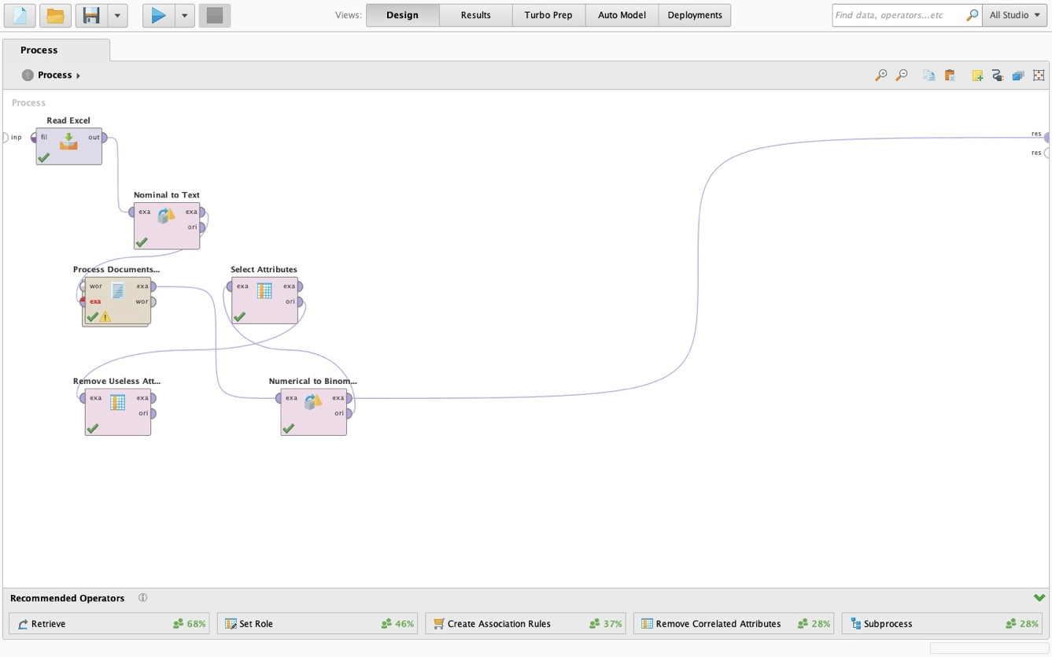

This is the process that was used find the results of the most popular breeds in the animal shelters of both cats and dogs.

The results are to follow down below.

In this dataset, we see all the dog breeds that are registered in the City of Dallas animal shelters. Since this was a lot of data to process, I took it into Excel and narrowed it down to the most popular dog breeds which is shown down below.

In this table we can see that the most popular breeds are Pitbulls, short haired Chihuahuas, German Shepherds, and Labrador Retrievers. With Pitbulls occupying the most population in animal shelters, I feel like there should be some type of program that showcases them to make sure that they find their forever homes. Pitbulls are often thought of as an aggressive breed which is why there is a lot of them in animal shelters.

Using the same process, let’s now analyze the most popular breeds for cats.

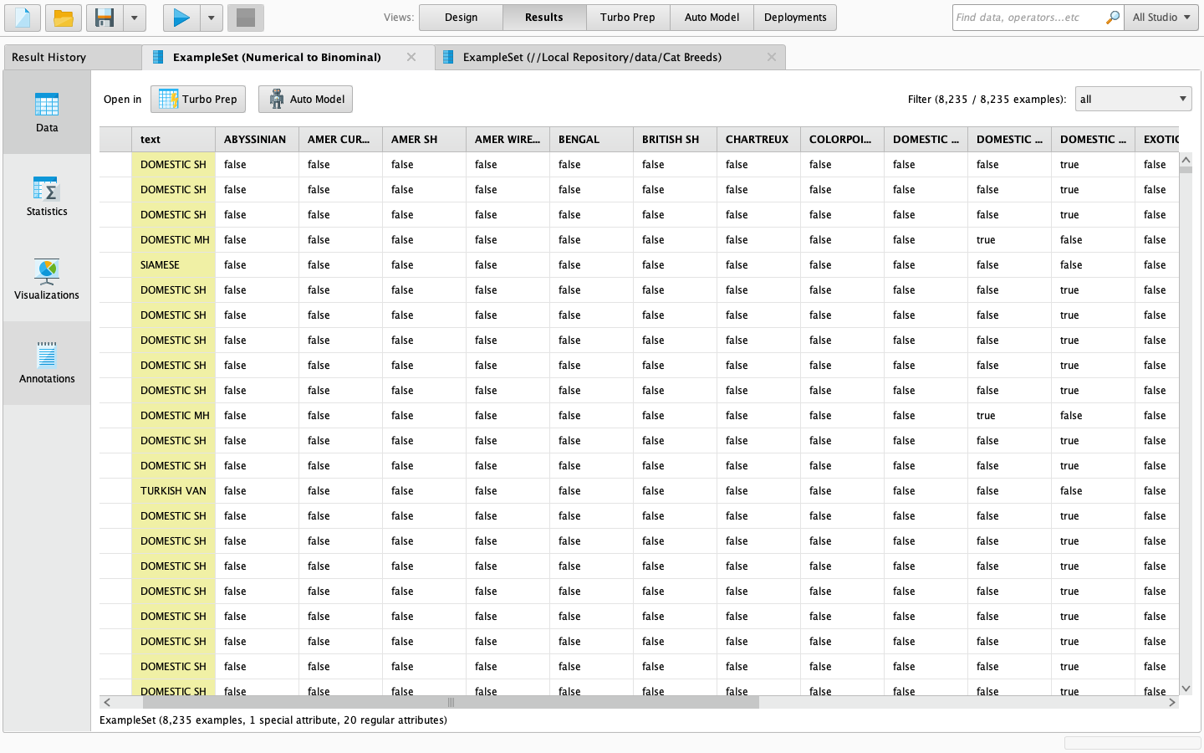

After seeing this data, I decided to import it into Excel to see if we can find the most popular breed for cats. The results are down below.



The most popular cat breeds are Domestic short hair and Domestic medium hair cats. These are the cats that occupy the animal shelters in the City of Dallas.

Now moving on to question two, we will be using K-clustering in rapidminer. Our target for using the K-clustering feature is to see how many animals were euthanized based on overpopulation and other conditions. The results are down below.

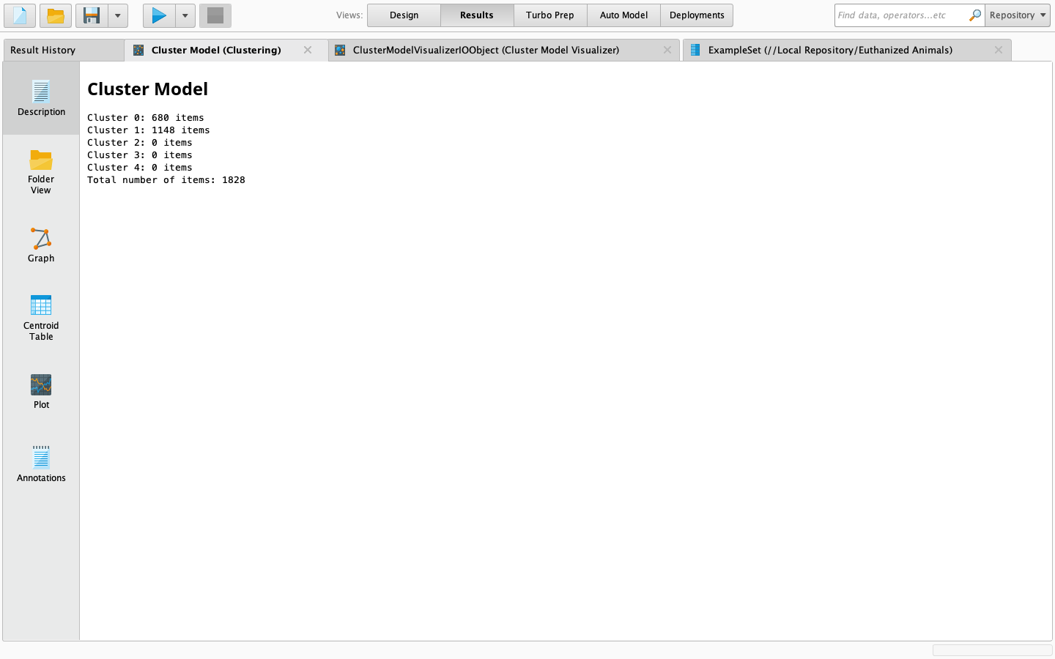

The results of running a K-clustering test show us that more dogs are euthanized compared to cats which is likely due to overpopulation or other conditions.

For question three, we will also be using the K-clustering feature in rapidminer to analyze the intake type and figure out why animals end up in animal shelters in the city of Dallas.

The results show us that strays are the most common intake type in animal shelters followed by owner surrender being the second behind it. Strays are very common to be walking the streets of the DFW area. Owner surrenders can happen for a numerous amount of reasons such as the owner is unfit to care for the animal, the animal isn’t compatible with children or other household pets, etc.

1. Conclusion and Limitations

The findings in this study can be used to help increase adoption rates in not only the City of Dallas animal shelters, but also animal shelters worldwide. We found that Pitbulls are the most common breed of dog in animal shelters which is probably due to their negative reputation as well as people don’t really notice this breed of dogs first. For cats, domestic short hair cats are the most popular breed. There are more dogs than cats in animal shelters which can be for a variety of different reasons. Since there is a bigger population of dogs, we found that more of them are most likely to get euthanized due to overpopulation.

The most common intake type is stray which did not surprise me just to how many stray dogs that I see around the city. With these findings, I am hoping that animal shelters can use events and other marketing techniques to highlight the less popular animals that usually have a hard time being adopted.

Some limitations of this project include not having a lot of numerical data. A lot of the data was categorical and made it a little bit harder to get accurate information. Another limitation was that I should have used more information from other major cities to compare the results to instead of just using the City of Dallas data.

AUTHOR CONTRIBUTIONS

For this project, I decided to work by myself independently meaning that I am responsible for all parts of the project. I, Haeven Butler am responsible for conducting the research for this project, determining the topic, providing the research questions, and completing the data analysis for this project. I am responsible for how the project is displayed and if I fully carry out the goal of this project.

REFERENCES

1. *11 Facts About Homelessness*. DoSomething.org.

https://www.dosomething.org/us.facts/11-facts-about-animal-homelessness

1. *Shelter Intake by Animal Type* | Dallas OpenData. Dallas Open Data.

https://www.dallasopendata.com/Services/Shelter-Intake-by-Animal-Type/d3vk-rqiw

1. Turner,P. , Berry, J., & Macdonald, S. (2012). Animal Shelters and animal welfare: raising the bar.

*The Canadian veterinary journal = La revue veterinaire Canadienne*, 53(8), 893-896.

1. Bradley, J., Rajendran, S. Increasing adoption rates at animal shelters: a two-phase approach to predict length of stay and optimal shelter allocation. *BMC Vet Res* 17, 70 (2021). https://doi.org/10.1186/s12917-020-02728-2
2. Martinez, A. (2022, May 12). *Dallas bans sale of cats and dogs at pet stores in effort to reduce puppy mill market*. KERA News. <https://www.keranews.org/news/2022-05-12/dallas-bans-sale-of-cats-and-dogs-at-pet-stores-in-effort-to-reduce-puppy-mill-market>
3. Brown, W., & Morgran, K. (2014). Age, Breed Designation, Coat Color, and Coat Pattern Influenced the Length of Stay of Cats at No-Kill Shelter. *Taylor & Francis Online*, 18(2), 169-180. https://doi.org/10.1080/10888705.2014.971156
4. Hennessy et al. (2001). Behavior and cortisol levels of dogs in a public animal shelter, and an exploration of the ability of these measures to predict problem behavior after adoption. *Science Direct*. 73(2). 217-233. <https://doi.org/10.1016/S0168-1591(01)00139-3>
5. Anderson, K., Brandt, J., Lord, L. & Miles, E. (2015). Euthanasia in Animal Shelters: Management’s Perspective on Staff Reactions and Support Programs. *Taylor and Francis Online*. 26(4). 569-578. <https://doi.org/10.2752/175303713X13795775536057>
6. Menor-Campos, D., Molleda-Carbonell, J., & Lopez-Rodriguez, R. (2011). Effects of exercise and human contact on animal welfare in a dog shelter. *British Veterinary Association*. 169(15). 388-388. <https://doi.org/10.1136/vr.d4757>
7. Stephen, J., & Ledger, R. (2010). An Audit of Behavioral Indicators of Poor Welfare in Kenneled Dogs in the United Kingdom. *Taylor & Francis Online*. 8(2). 79-95. https://doi.org/10.1207/s15327604jaws0802_1

GITHUB LINK